

REPORT
REPORT TO: | Mayor Rick Bonnette and Members of Council
REPORT FROM: | Ted A. Drewlo, Manager of Engineering Services
DATE: | September 12, 2012
REPORT NO.: | INF-2012-0036
RE: | GTA West Corridor Planning and Environmental Assessment Study Additional Analysis in Halton Area

RECOMMENDATION:

THAT Report No. INF-2012-0036, dated September 12, 2012, regarding GTA West Corridor Planning and Environmental Assessment Study Additional Analysis in Halton Area, be received;

AND FURTHER THAT the Town of Halton Hills supports the completion of Stage 1 based on the information presented by the Ministry of Transportation at the Public Information Centre held in June 2012; subject to:

The preliminary route planning area for Stage 2 be revised to the Ninth Line or at a minimum to remove the residential properties fronting on Eighth Line and therefore the uncertainty associated with their properties given the length of time required to complete the Environmental Assessment and define the corridor;

AND FURTHER THAT the Ministry of Transportation be requested to immediately commence Stage 2 of the GTA West Corridor Planning and Environmental Assessment Study;

AND FURTHER THAT the Ministry of Transportation be requested to work with Regional and local area municipal staff to ensure that the impact of the proposed highway facility on the existing properties is minimized;

AND FURTHER THAT the Ministry of Transportation utilize the work completed as part of the Halton-Peel Boundary Area Transportation Study, specifically the East-West Connection and the transportation challenges around the Hamlet of Norval, during Stage 2 of the Environmental Assessment;

AND FURTHER THAT staff be directed to report back after the Transportation Development Strategy has been released.

BACKGROUND:

The Ministry of Transportation (MTO) has been undertaking the GTA West Corridor Planning and Environmental Assessment Study over the past number of years. A Public Information Centre (PIC) was held at the Gellert Community Centre on June 12, 2102. Attachment 1 is a one page summary of the additional analysis in the Halton area conducted by the MTO.

COMMENTS:

The MTO is nearing the completion of Stage 1 of the GTA West Corridor Planning and Environmental Assessment Study. The Transportation Development Strategy (TDS) report will be completed this fall. The draft TDS was released in March of 2011 that suggested a combination of Alternatives 4-2 and 4-3 would provide the best solution to the transportation issues in the GTA West Corridor. In response to Halton area input, further analysis and consultation was carried out. The additional assessment provided a more in-depth and detailed exploration of the various focused areas, including community, cultural, agricultural, land use planning, natural environment, economy, transportation, road design, constructability and costs.

At the PIC in June, the MTO provided the public with their additional analysis work in Halton and recommendations. The additional analysis by the GTA West Corridor Study Team (Study Team) considered three options in the Halton area: A new corridor, further 401 widening to 12 lanes, and further 401 widening to 14 lanes. The Study Team concluded that a further widening of Highway 401 to 12 lanes through Halton Region was the preferred alternative, as it would provide minimal impact to: Agricultural lands, agricultural economy, cultural heritage, and rural character of the community. The Study Team also found that the preferred alternative: Better reflects the land use planning and policies in local municipalities as established in their respective official plans, traffic demand forecast to 2031 will be accommodated, and the widening could be designed to provincial design standards with retaining walls proposed to mitigate property impacts. The preferred alternative had the lowest cost estimate of the three options. The best balance of benefits and impacts is provided with this preferred alternative. Attachment 2 shows the proposed preliminary route planning study area. It is important to note that the Study Team did not re-evaluate all of the alternatives for the entire corridor, but only focused on connecting to Highway 401 through Halton. Previous work discounted the other series 4 alternatives, such as going north of Halton Hills to connect to the Guelph area.

One area of concern noted by staff was the magnitude of the study area within Halton Hills for Stage 2 of the Environmental Assessment. While staff appreciate the need to not limit alternatives by scoping the study area at this stage, it is unlikely the new corridor will need to align with the Eighth Line. Staff recommends that the MTO be requested to adjust the preliminary route planning study area to the Ninth Line or at a minimum to the east side of the settlement properties on Eighth Line to provide some certainty to these residents given the length of time required to complete the Environmental Assessment Study.
As a number of properties in Halton Hills are included in the preliminary route planning study area, staff recommends that the MTO proceed immediately with the next stage of the Environmental Assessment after the TDS report is completed. It is recommended that the MTO continue to work closely with area municipal and regional staff to ensure the impact on the existing properties is minimized.

As MTO moves into Stage 2 of the GTA West project, an opportunity exists to address some of the transportation challenges in the Norval area that was identified in HPBATS. By carefully considering the alignment of the new highway, along with interchange locations and modifications to the local and regional road network, the east-west capacity issues across the Credit River could be addressed. Staff is requesting that MTO utilize the work completed in HPBATS during the Stage 2 process.

This is an interim report on the GTA West Corridor Planning and Environmental Assessment Study. The TDS report will be released shortly, and staff will provide information to Council on the details of the finalized report.

Presentation from Resident

At the Council meeting of September 10, 2012, Council received a presentation from a resident on Eighth Line, north of Steeles Avenue, regarding concerns with the GTA West Corridor and Environmental Assessment Study. Attachment 3 shows the Transportation Summary prepared by the Study Team, and confirms the source of the material presented by the resident. This summary is only for the three options considered by MTO to connect to Highway 401 through Halton and does not include the other alternatives previously assessed and discounted. It is important to note that while the preferred alternative will provide less overall network performance, it does satisfy the transportation needs to 2031 as required in the Terms of Reference for the Environmental Assessment Study. A brief history of the Environmental Assessment process by the MTO is provided.

The work by the Study Team has been on-going since 2007. Alternatives were explored and public information centres held throughout the process. A new highway corridor from Highway 400 to Highway 401 in the west end was the preferred alternative throughout the process to achieve the transportation system requirements.

Five alternatives for new highways were developed in the process to bring a new highway from Highway 400 to Highway 401 or areas west of Milton. While other alternatives may have been available to the Study Team, none were developed at the time.

Through the Environmental Assessment process, Alternative 4-3 was introduced as the preferred alternative. Based on the analysis, the Study Team did not recommend the other four Alternatives 4-1, 4-2, 4-4 or 4-5. Serious concerns were raised in Halton regarding the agricultural, social and cultural impacts of the proposed highway. Council for the Town of Halton Hills authorized staff to have an independent consultant review the results from the Study Team. The consultant team for the Town included expertise in Planning, Environmental, Agriculture, Transportation and Environmental Assessment process. The consultant’s review supported a response to the Study Team. Comments were submitted to the Study Team, as authorized by approved recommendations from Report No. INF-2011-0035.

The March 2011 draft TDS indicated that Highway 401 could not be widened to 12 lanes. Staff had concerns with the statement and requested authorization for an independent consultant to review Highway 401 through Halton. This review conducted by the consultant retained by the Town found that Highway 401 could be widened to 12 lanes, if an urban standard was implemented. This work was presented to the Study Team. The consultant work was supplementary to the Environmental Assessment work being carried out by the Study Team and was not comprehensive of all traffic matters, as noted by the resident in his presentation. The primary purpose of this work was to have MTO re-consider the practicality of widening Highway 401.

Many factors are taken into consideration by the Study Team during the Environmental Assessment work. After a detailed analysis of all the factors, the Study Team recommended Alternative 4-2 with widening of Highway 401 to 12 lanes as the preferred alternative. Attachment 4 shows the summary of technical findings based on all impacts evaluated in this Environmental Assessment. The Environmental Assessment process is an evaluation of problems and opportunities and a comparison of alternatives. There are benefits to a new corridor. It would provide additional transportation capacity and economic benefits. There are negative impacts of a new highway corridor. This construction would have the highest impact on natural environment, cultural environment, agriculture, land use and the community. Again, it is important to note that the comparative assessment is only between the three options in Halton to connect the new corridor to Highway 401, and does not re-evaluate the previously discounted alternatives.

The analysis found that considerably more social and environmental impacts would be expected with a new corridor through Halton Hills, and that widening Highway 401 to 12 lanes would provide the essential transportation needs to 2031, at the lowest cost. The Study Team concluded that the preferred alternative will provide the best balance of benefits and negative impacts. Further information on the GTA West Corridor Planning and Environmental Assessment Study is available on the GTA West website.

It is expected that additional information will be made available with the release of the Transportation Development Strategy. Staff will report back to Council after the Study Team has completed this report.

RELATIONSHIP TO STRATEGIC PLAN:

The Preferred Alternative 4-2 will be recommended in the TDS for the GTA West Corridor Planning and Environmental Assessment Study. This alternative will have less Environmental, Agricultural and Cultural impacts in Halton Hills and is more consistent with the Community Vision to 2031.

FINANCIAL IMPACT:

There is no direct financial impact resulting from this report. Staff will continue to monitor the progress of the Provincial Environmental Assessment.

COMMUNICATIONS IMPACT:

A copy of this report will be forwarded to the Minister of Transportation, the Minister of Municipal Affairs and Housing, and the GTA West Corridor Planning and Environmental Assessment Study Team, as comments from the Town of Halton Hills.

SUSTAINABILITY IMPLICATIONS:

The outcomes of the MTO Study will impact a number of the pillars of sustainability, as it will result in a new major transportation corridor within the boundaries of the Town of Halton Hills.

CONSULTATION:

Staff consulted with Planning, Development and Sustainability staff and Halton Region staff during the preparation of this report.

CONCLUSION:

The Ministry of Transportation is nearing the completion of Stage 1 of the GTA West Corridor Planning and Environmental Assessment Study. A Public Information Centre was held at the Gellert Community Centre on June 12, 2102. The Transportation Development Strategy (TDS) report will be completed this fall.

The Alternative 4-2 was the preferred road improvement. The proposed highway will be from Highway 400 in York and connect west of the Halton-Peel boundary at the Highway 401 and 407 interchange, and Highway 401 will be widened to 12 lanes in Halton Region.

Staff will provide additional comments on the TDS report after it is completed. Staff recommends that this report and comments be forwarded to the MTO for inclusion in their Environmental Assessment Study.

Respectfully submitted,

Ted A. Drewlo, P. Eng.  Manager of Engineering Services |  | Chris G. Mills, P. Eng.  Director of Infrastructure Services & Town Engineer

Dennis Y. Perlin
Chief Administrative Officer

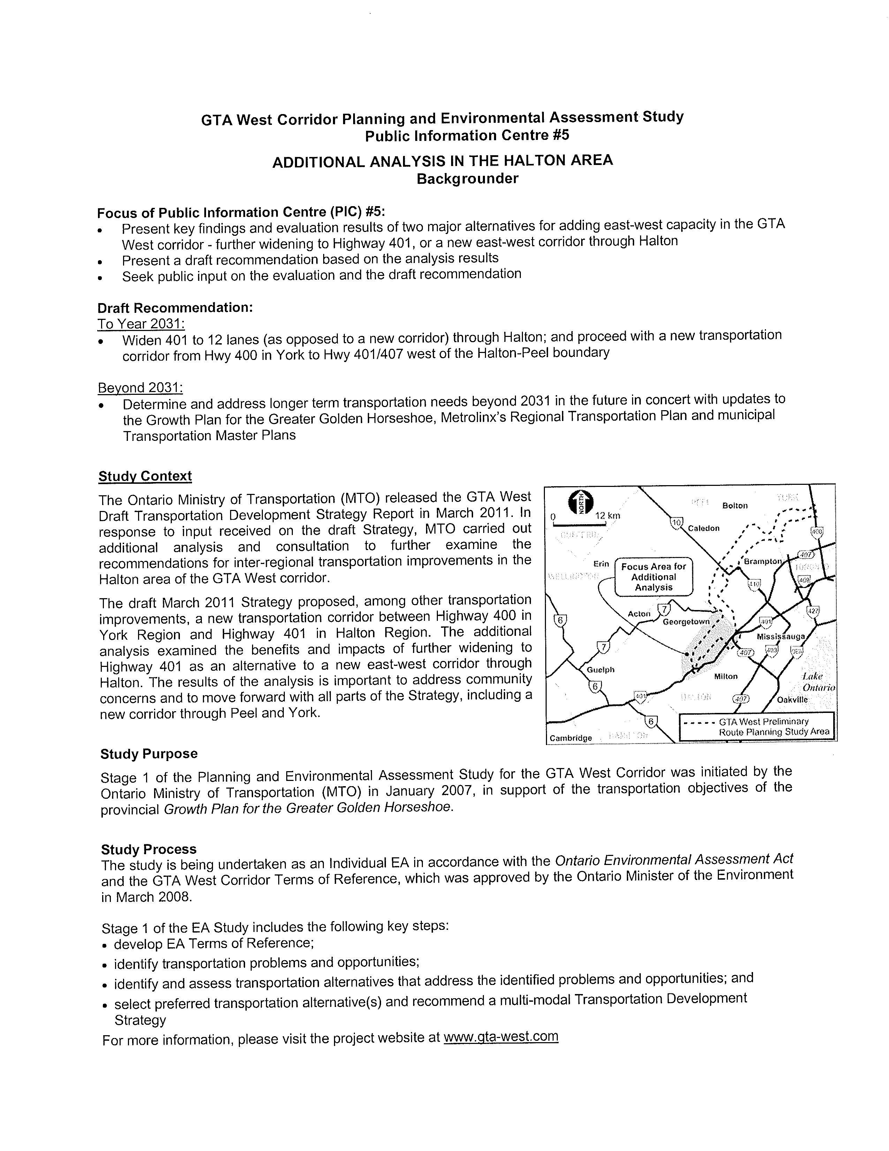
Attachment 1
Attachment 2

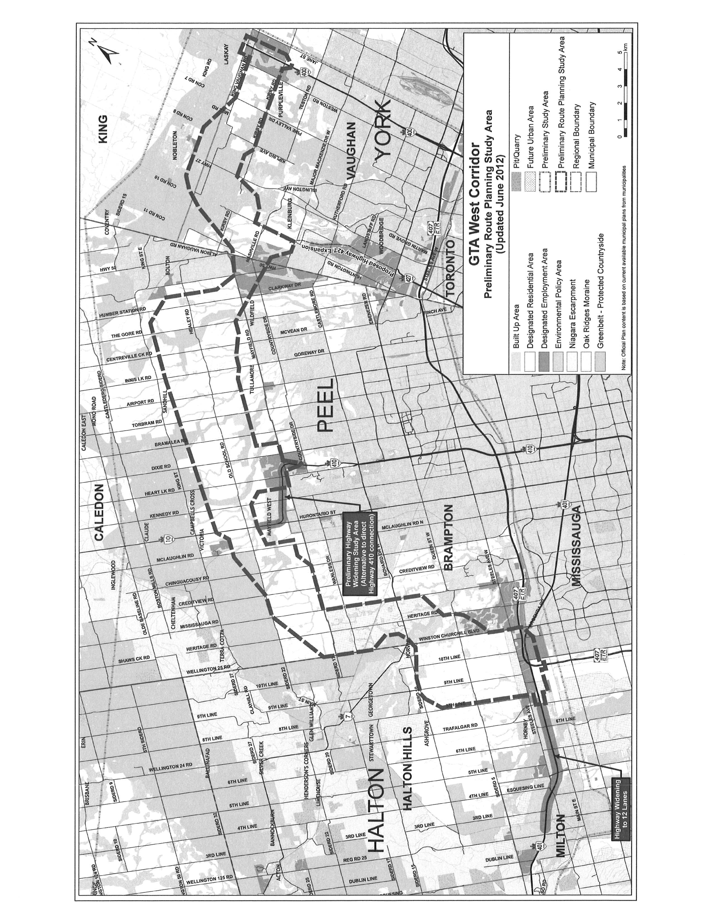

Attachment 3

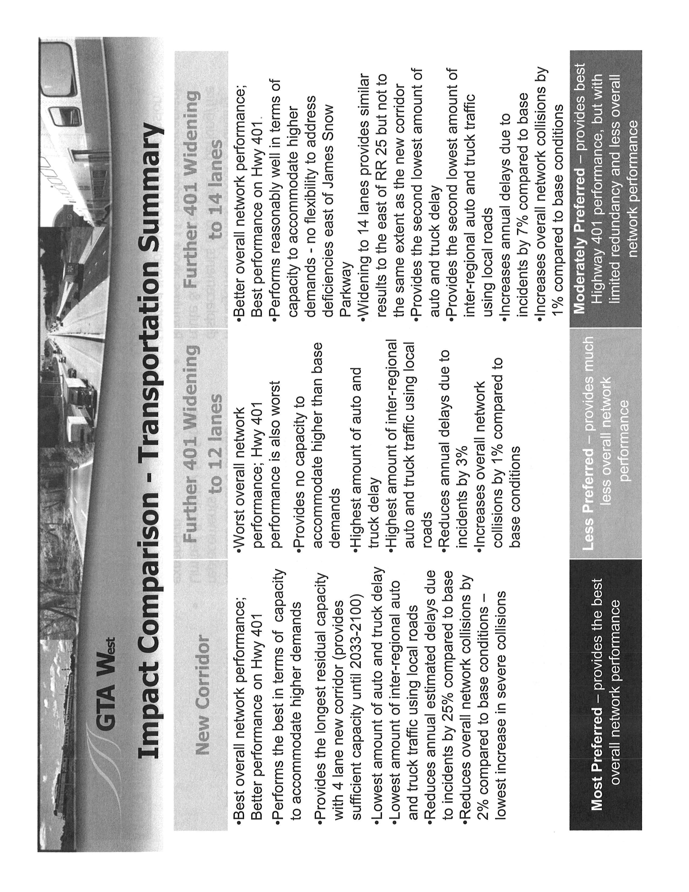

Attachment 4



